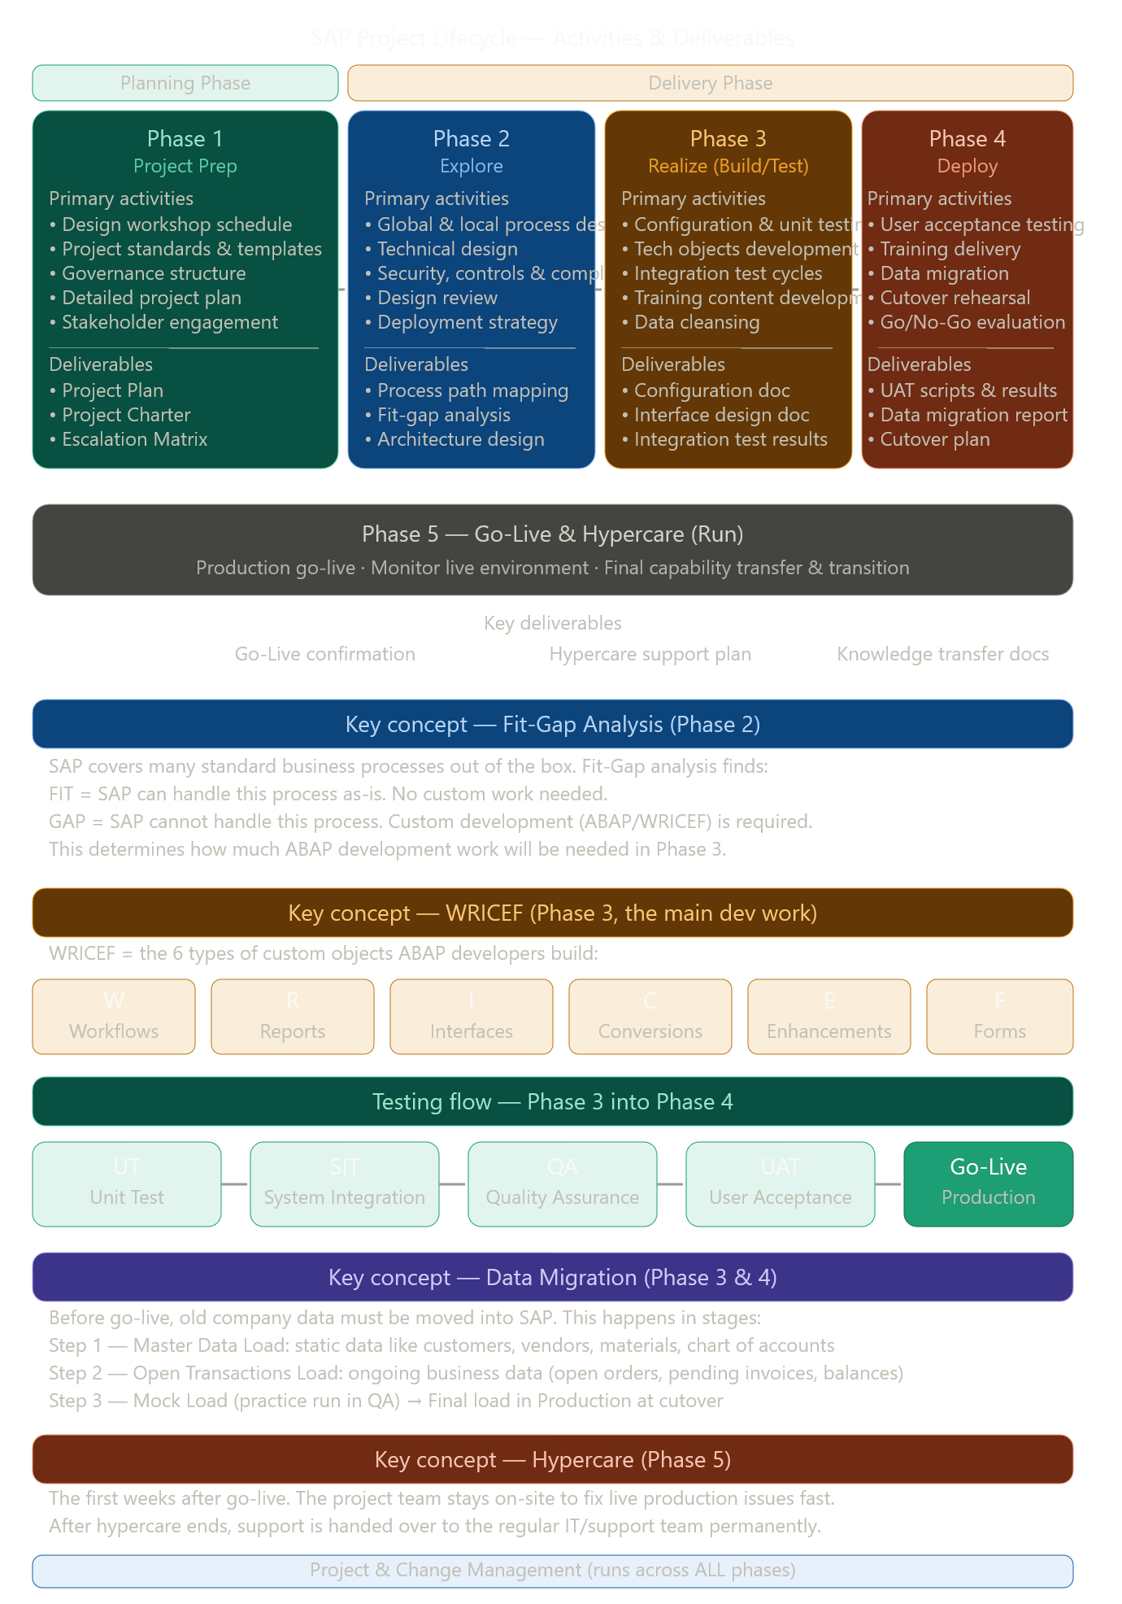
This image is the same 5-phase journey as before, but now it shows you what you actually do and what you produce in each phase. Here's the simple explanation:
The two big zones — the image splits the project into a Planning Phase (Phase 1–2) and a Delivery Phase (Phase 3–5). Running below all of it is "Project & Change Management," which never stops — you're always tracking progress, managing risks, and handling communication.
What each phase adds:
Phase 1 (Project Prep) is about setting up your tools and structure — templates, schedules, governance rules, and getting the right people involved. You produce the Project Plan and Charter.
Phase 2 (Explore) is the investigation phase. You map all business processes, do Fit-Gap Analysis (what SAP handles vs. what needs custom code), and write Functional Specs. This decides how much development work Phase 3 will need.
Phase 3 (Realize) is the build and test phase — the most technical one. ABAP developers build all the WRICEF custom objects, and the system goes through four rounds of testing: Unit Test → SIT → QA → UAT.
Phase 4 (Deploy) is about moving everything to the production server and preparing the business. Users are trained, data is migrated, a Cutover Rehearsal is done (a practice run of go-live), and then the Go/No-Go decision is made.
Phase 5 (Go-Live & Hypercare) is when the system goes live. The team stays close for the first few weeks to fix any real-world issues quickly — this is called Hypercare. After that, the project officially ends and support is handed to the regular IT team.
The thread connecting it all: Data, testing, and training run across multiple phases — they don't happen once. That's why the image shows them with activities spread across Phase 3 and 4.

